RESUME
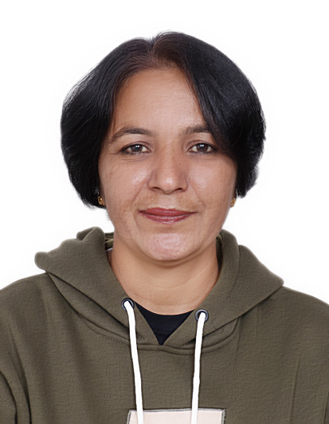

NEETU DAHIYA
DOB: 23/05/1979
C-03, Amba Apartment, Sector 10
Dwarka, Delhi.
PH: 00971-509970549
Email: dahiya.neetu@yahoo.com

Career Objective:

Seeking employment as a Physical Education Teacher with a reputed school and to be a part of competitive & nurturing work environment and a profession that evolves growth and advancement.

Academic Qualification

- M.P.ED Masters in Physical Education from Barkatullah University.
- B.P.ED Bachelor in Physical Education from Barkatullah University.
- Graduation B.A Pass from Miranda House North Campus, Delhi University.
- 10+2 CBSE, Motilal Nehru School of Sports, Rai Sonepat, Haryana
- Certificate in Computer Knowledge from Canadian University.

Specialization in Volleyball.

Summary of skills

- Excellent team management skills.
- Sound knowledge of physical fitness.
- Profound ability to conduct students exercises and practice sessions.
- Proficient at Aerobics, Basketball, Tennis, Badminton and Yoga.
- Immense ability to keep students motivated, active and promote healthy lifestyle choices through hands-on activities.

Work Experience:

- Presently working in The Indian International School (The Indian High Group of Schools) Dubai from 25th Nov.2006 and now working as P.E Coordinator till Date.

- In charge of the overall sports activities/curriculum for grade K-10
- To plan, develop and deliver high quality sports lessons using a variety of approaches to continually enhance students’ interest and participation.
- To monitor student progress and to train and encourage them for Inter school competition.
- Organizing After school sports activities and weekend sports club.
- Play a key role for the school in organizing various activities such as International Yoga Day, Republic Day parade and mass drill, Sports Day and any other fests celebrated in U.A.E.
- Conducting Fire Mock Drill in the school.
- Organizing one month Programme for Dubai fitness challenge (30x30) for students, teachers/ non-teaching, and parents in school.
- Any additional work assigned to me by the principal or school management.

- Worked in Inderprastha International School, Dwarka, New Delhi. from 1st August 2005 to Sept.2006 as a P.E. Teacher.

- Worked in D.P.S. international, Saket as P.E. teacher from 2002 to 2005.

- Worked with American Embassy School, Chanakya Puri, as an Assistant P.E. Teacher for 3 months (2002).

- Worked with Army Public School, Dhaula Kuan, New Delhi as a P.E. Teacher for 1 Year (2001).

Achievements In Volleyball (India)

- Represented Haryana State in Sub-Junior National held at Jodhpur(18th – 22nd Oct. 1993) and Secured 4th place.
- Represented Haryana State in Sub-Junior National held at Calcutta(22nd – 26th Dec. 1994)

- Represented National School Games from Haryana held at Chandigarh (Nov-27th – Dec-3rd in 1995).
- Represented Haryana State in Junior National held at Salem (Tamilnadu)(11th – 16 Jan. 1996).
- Represented Haryana State in the National School Games held at Rewa (M.P) in 1996.
- Represented Haryana State in the Senior National held at Calcutta in 1996.
- Represented Haryana State in the National Games held at Bangalore in 1997.
- Represented Delhi State in the Senior National Games held at Visakhapattnam (A.P) in 1997.
- Represented Delhi University in the Inter Univ. Competition at zonal level and All India University level held at Amritsar in 1997. Secured 3rd Place.
- Represented Delhi State in the Senior National Games held at CHINSURA (W.Bengal) in 1998.
- Represented Delhi State in the Youth National Games held at Chikhballpurm (Karnataka) in 1999.
- Represented Delhi State in the Senior National Games held at Salem (Tamil Nadu) in 2000.
- Represented Jaunti Club in Delhi Sports festival placed 2nd Place in 1999.
- Represented Jaunti Club in the Senior State Championship placed 1st Place in 1998, Delhi.

- Represented Jaunti Club in the Senior State Championship placed 1st Place in 1999, Delhi.
- Represented Jaunti Club in II Delhi State Invitation Tournament and secured 1st Place in 1998, Delhi.
- Represented MNSS Rai School in the School state and placed 1st Place in 1991, Haryana.
- Represented MNSS Rai School in Sub Junior Championship and placed 2nd in 1992 Haryana.
- Represented MNSS Rai School in Junior Volleyball Championship and placed 2nd in 1996 Haryana.
- Represented MNSS Rai School in State Middle/ High/ Sr. Sec. School Tournament and secured 1st Place in 1996, Haryana.
- Represented Rai school in State Middle/ High/ Sr. Sec. Schools Tournament and placed 1st position in 1995.
- Represented MNSS Rai School in State Middle/ High/ Sr. Sec. School Tournament and Secured 1st Place in 1992.
- Participated in Inter House Athletic meet in High Jump and placed 2nd in 1995.
- Represented the House in the Shot-put event in the Inter House Athletic meet and placed 1st in 1995.
- Represented the House in the Shot-put event in the Inter House Athletic meet and placed 3rd in 1994.
- Represented the House in the Shot-put event in the Inter House Athletic meet and placed 3rd in 1990.
- Attended the Workshop of Mini Lawn Tennis was organized for DPS for P.E Teachers by AITA (All India Tennis Association) in Delhi.

Award

- Got the Best Sports Women Award from Miranda House, New Delhi in 2000.

May 12, 2023 (Neetu Dahiya)

